-------------------------------------------------------------------------------------------------------------------------------NAME: ARCHANA DEVI.P
REG NO: 192521192
COURSE: SOFTWARE TESTING
CODE: CSA0923
LAB PROGRAMS
17. White-Box JUnit Test Case to Find the Maximum of Three Numbers
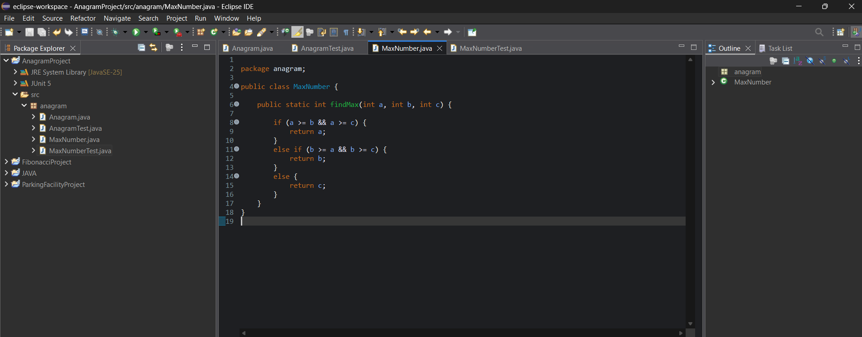

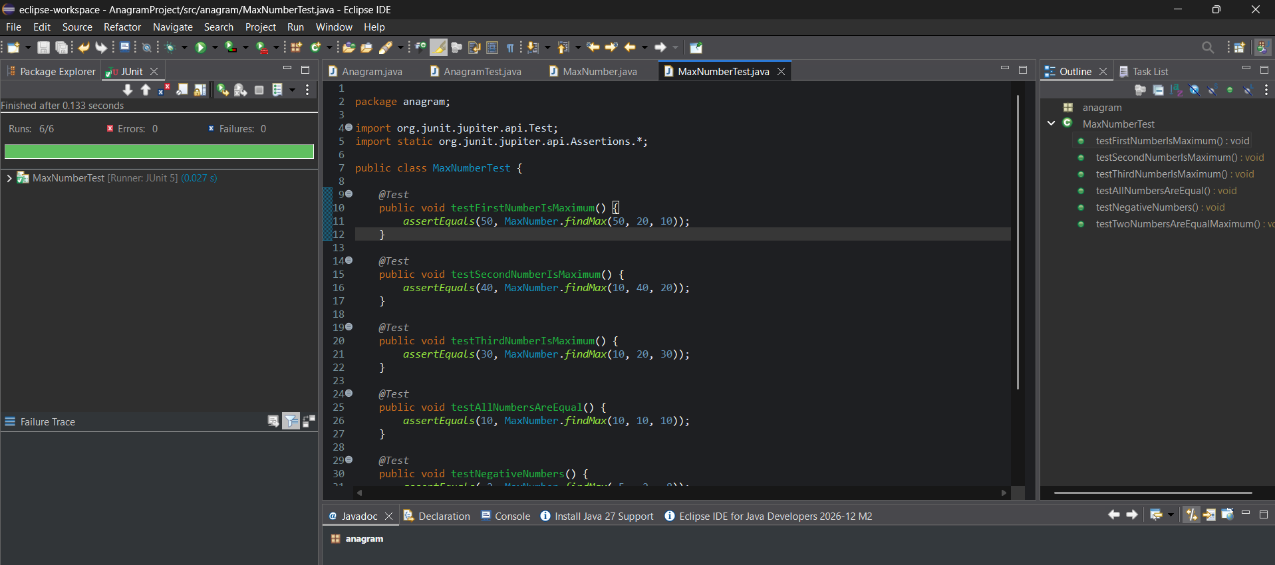
Result: The maximum of three numbers was successfully determined using Java. Six JUnit test cases were executed to verify different conditional branches, equal values, and negative numbers. All six test cases passed successfully, provided the execution results confirm this.

